1st meeting of European Thematic Smart Specialisation Partnership ‘Smart Sensors 4 Agri-Food’

Connecting competences, facilitating digital transformation
On February 21st the members of the Thematic Smart Specialisation Partnership ‘Smart Sensors 4 Agri-food’ met at CTIC in Gijón Technology Park (Spain). The core topic of the agenda was the agreement on the governance structure of the partnership and the work plan for the near future. Additionally, the chairs for the partnership were elected.
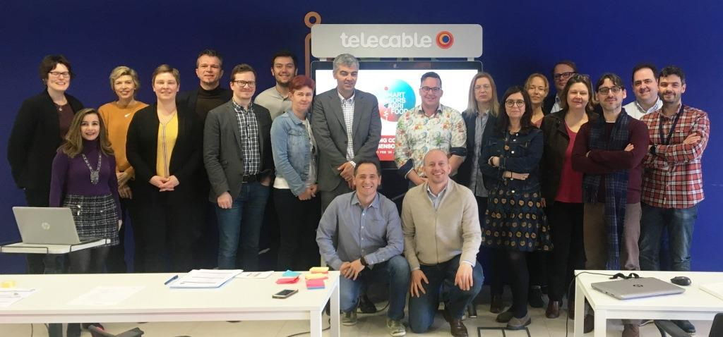
Representatives of the members of the Thematic Smart Specialisation Partnership ‘Smart Sensors 4 Agri-food’ met in Gijón.
18 clusters and research partners from 14 European regions set themselves the goals of boosting the digital transformation of the agri-food sector and facilitating access to applicable solution for industry. By connecting competences across Europe the partners as well as their members and stakeholders will gain a better understanding of agri-food´s opportunities, challenges and requirements for digital technologies.
Four core challenges are identified and will be initially addressed within the platform:
- Match the needs of agri-food companies with the solutions and capabilities of the technology and digital solution providers and building a “trust zone” between the involved sectors.
- Roll out a step-by-step approach to digital transformation by creating cross-border innovation communities and providing funding opportunities.
- Develop and demonstrate the integration of digital technologies in the production lines with their specific requirements for robust solutions.
- Adopt and establish vocational and professional training programs for companies and their employees.

The meeting was held adjacent to the program of study visits and matchmaking events, which were organized within the two European projects originating from the partnership: “Smart Sensor Systems for Food Safety, Quality Control and Resource Efficiency in the Food Processing Industry” (S3FOOD) and “Connecting smart sensor systems for the food industry” (Connsensys). S3FOOD provides support to SMEs and a dedicated funding scheme for developing and implementing technologies and digital solutions in the food processing industry. Connsensys focuses on the role and potential of living labs in the innovation eco-system for the digital transformation of the sector. Moreover, this projects paves the way to the network of living labs that will form a cornerstone in the SS4AF strategy.
“It will be a long way, but based on the established relations to our companies and the focus on applicable solutions, we will generate real added-value for our companies and regions with our partnership”, stated Simon Maas, AgriFood Capital BV (The Netherlands) after he was elected to be the first chair of Smart Sensors 4 Agri-food. Cécile Guyon from Bretagne Dévelopement Innovation (France) and elected vice-chair added: “Connecting competences across European regions is an important key to successfully support SMEs and to facilitate their digital transformation processes. This is why I am happy to be part of this unique partnership.” Flanders’ FOOD (Belgium) will host the Brussels-based head office of the partnership.
If you want to stay updated just send an e-mail to the contact person below and you will receive the latest news on the partnership and its projects.

Contact details head office:
Veerle Rijckaert
veerle.rijckaert@flandersfood.com
+32 478 333 812

